The table below shows the number of private and public schools in each district

private public
isiolo 1 0
kirinyaga 3 12
maragua 3 22
nyandarua 1 4
nyeri 3 10
thika 1 0
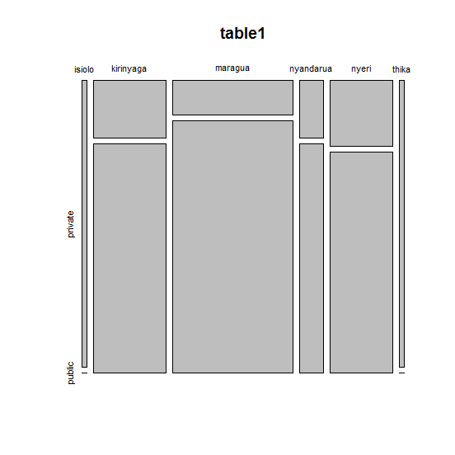

The plot below shows a representation of the number of private and public schools per district

